* Analysis of middle and small business projects and relation of budget of project and their revenue.
* The goal of this project is to clearly understand the main factors of grow up the middle and small business.
* To better understand this goal, I used a linear regression model with one feature to describe the revenue of the project as a function of the budget of whole project.

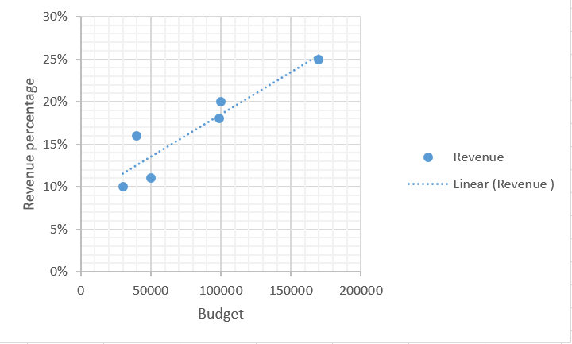

The figure depicts the model (**blue**) plotted against the actual data points.

This result suggests that budget may have a very positive impact on the project revenue however as we know it is just a main factor but not the only factor that effect on the grow the revenue of medium and small business.